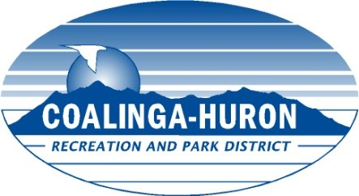

BOARD OF DIRECTORS
BOARD MEETING SCHEDULE
JANUARY 2022 – DECEMBER 2022

THURSDAY, JANUARY 13, 2022 Chesnut Building, Huron

THURSDAY, FEBRUARY 10, 2022 Keck Community Ctr, Coalinga

THURSDAY, MARCH 10, 2022 Chesnut Building, Huron

THURSDAY, APRIL 14, 2022 Keck Community Ctr, Coalinga

THURSDAY, MAY 12, 2022 Chesnut Building, Huron

THURSDAY, JUNE 9, 2022 Keck Community Ctr, Coalinga

THURSDAY, JULY 14, 2022 Chesnut Building, Huron

THURSDAY, AUGUST 11, 2022 Keck Community Ctr, Coalinga

THURSDAY, SEPTEMBER 8, 2022 Chesnut Building, Huron

THURSDAY, OCTOBER 13, 2022 Keck Community Ctr, Coalinga

THURSDAY, NOVEMBER 10, 2022 Chesnut Building, Huron

THURSDAY, DECEMBER 8, 2022 Keck Community Ctr, Coalinga

Regular Board meetings begin at 6:00 PM. Board meetings are usually scheduled on the second (2nd) Thursday of each month.

Board Adopted: Keck Community Center, 555 Monroe Street, Coalinga
Chesnut Building, 16501 W. Palmer Ave, Huron

